REQUEST TO ADD VEHICLES TO SCHOOL DISTRICT MASTER VEHICLE POLICY
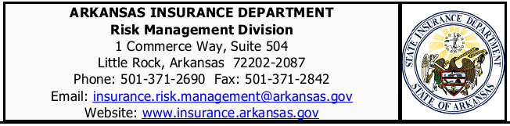
COMPLETE THE FOLLOWING FOR EACH VEHICLE TO BE ADDED TO THE PUBLIC SCHOOL VEHICLE POLICY
Check Yes or No to request Physical Damage (Comprehensive and Collision) Coverage.
Print or type School District LEA code, School District Name and School District representative and date.
Return completed Request to Add Vehicle form to the Risk Management Division via fax (501-371-2842) or email (insurance.risk.management@arkansas.gov).

*To request deletion of vehicles or changes to vehicles currently insured, indicate changes on current
Schedule of Covered Vehicles Report, sign, date and return the schedule to the Risk Management Division at the fax number or email address listed above.

Year | Make/Model | Vehicle Identification Number  (Include Compete VIN) | Original Cost | Add Comp/Coll Coverage | (30 Days or More) Leased Vehicles | (29 Days or Less) Rented Vehicles
 |  |  |  | ☐Yes ☐No | ☐Yes ☐No | ☐Yes ☐No
 |  |  |  | ☐Yes ☐No | ☐Yes ☐No | ☐Yes ☐No
 |  |  |  | ☐Yes ☐No | ☐Yes ☐No | ☐Yes ☐No
 |  |  |  | ☐Yes ☐No | ☐Yes ☐No | ☐Yes ☐No
 |  |  |  | ☐Yes ☐No | ☐Yes ☐No | ☐Yes ☐No
 |  |  |  | ☐Yes ☐No | ☐Yes ☐No | ☐Yes ☐No
 |  |  |  | ☐Yes ☐No | ☐Yes ☐No | ☐Yes ☐No
 |  |  |  | ☐Yes ☐No | ☐Yes ☐No | ☐Yes ☐No

Please complete this section if Certificate of Insurance is Required.
(All Information Must be Completed)
District LEA No. |  | District Name
Phone Number |  | District Contact Person
District Contact Email Address
Date of Request
☐ | ☐
Loss Payee | Additional Insured | Lease/Rental Period
Additional Insured/Loss Payee Name |  |  | Additional Insured/Loss Payee Contact Name
Additional Insured/Loss Payee Mailing Address
Additional Insured/Loss Payee Email Address |  |  | Contact Phone Number

